Create PrintFleet Agent

1) Log in to leemic.printfleet.com

2) Select Administration tab and DCAs

3) Select group from dropdown list (London, Stockport, Scotland)

4) Select New DCA and Create New Group

5) For Type choose Generic and enter customer name in both Name fields

6) Select Create Group and DCA, from here you can either email the link to the customer for installation or download the agent. Choose operating system and download

7) Under Device Views, Technical View tab you should see the created customer under group

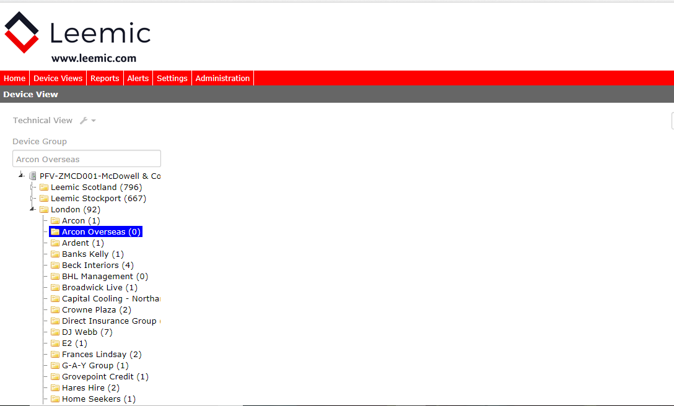

To Run Agent

1) Double click on downloaded PrintFleet DCA Pulse file (or right click and run as administrator)

2) Choose Full Installation, both boxes should be ticked, .NET Framework will automatically be installed if needed. Click Next and on next screen click install.

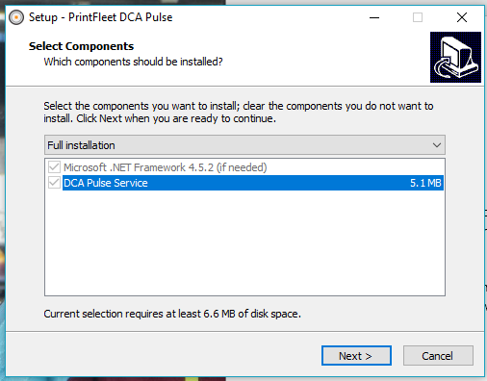

To Check Agent Is Running

1) Log back in to leemic.printfleet.com

2) Select Administration, DCAs and choose group agent was created in (London, Stockport, Scotland)

3) If running ok you will see Connected, if not Pending Activation

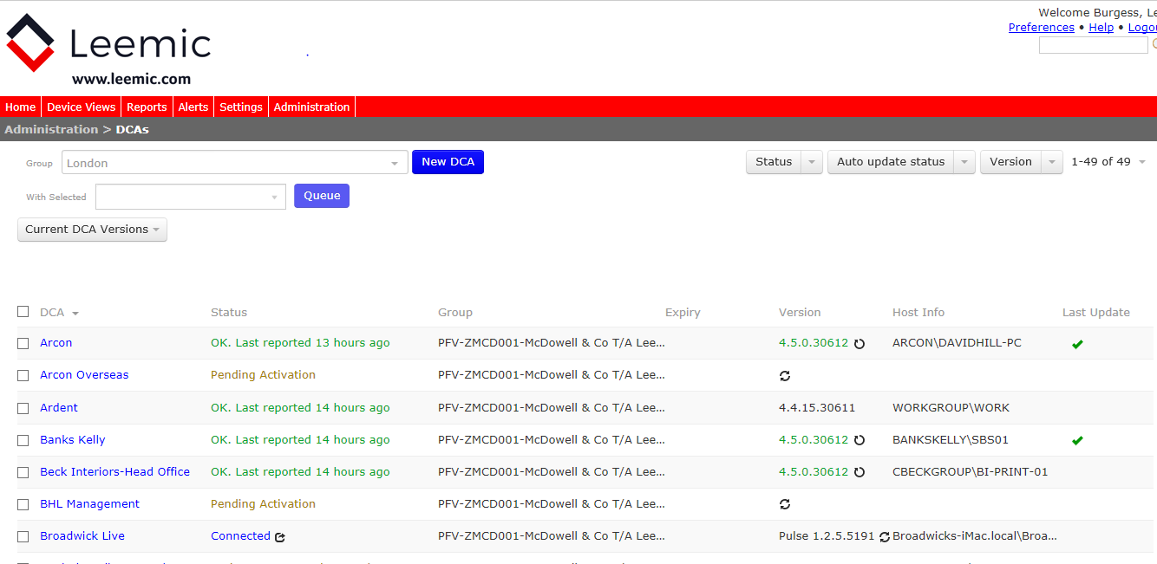

4) Devices may not show up straight away but to check select Device Views, Technical View and select customer.

